Russian Federation
MINISTRY OF EDUCATION AND SCIENCE
FEDERAL STATE BUDGETARY
EDUCATIONAL INSTITUTION OF HIGHER EDUCATION
«Orel State University
named after I. S. TURGENEV»
Institute of Instrument Engineering, Automation and Information Technology
Department of Information Systems and Digital Technologies

Project work
on the subject:
" Сybersecurity in the modern world”

By Korolev Anton
Group: 31PI

Orel, 2025

INTRODUCTION

Relevance
In today's digital era, cybersecurity has become a critical concern for individuals, businesses, and governments worldwide. The rapid advancement of technology, increasing reliance on digital infrastructure, and the growing sophistication of cyber threats highlight the urgent need for robust cybersecurity measures.
It is factors such as the constant growth of cyber threats, the digital transformation of society, attacks that have huge economic consequences, non-compliance with regulatory requirements in companies, national security issues and lack of public awareness that have led to the creation of such an area as cybersecurity.

Project Goal
To study and try to find out what cybersecurity is, to understand why it is needed, what functions it performs and what role it plays in the modern world.

Project Objectives
- To define what cybersecurity is and find out what it is for.
- Learn the history of cybersecurity.
- Learn the goals of implementing cybersecurity.
- Find out the types of modern cyberattacks.
- Get acquainted with the main trends in cybersecurity.
- Learn methods to protect and prevent cyber threats.

CONTENT
CONTENT
INTRODUCTION
- WHAT IS CYBERSECURITY
  - Definition of cybersecurity
  - The difference between cybersecurity and information security
  - Cybersecurity objectives
- THE HISTORY OF CYBER THREATS
- THE MAIN TRENDS IN CYBERSECURITY
  - Cybersecurity risks when working remotely
  - The increase in the number of ransomware programs
  - An increase in the number of cloud services and threats to the security of cloud infrastructure
  - Smart Social Engineering Attacks
  - Data privacy as a discipline
  - Improving multi-factor authentication
  - The active growth of artificial intelligence
- TIPS FOR PROTECTING AND PREVENTING CYBER THREATS
- CONCLUSION
- BIBLIOGRAPHY

- WHAT IS CYBERSECURITY
1.1 Definition of cybersecurity
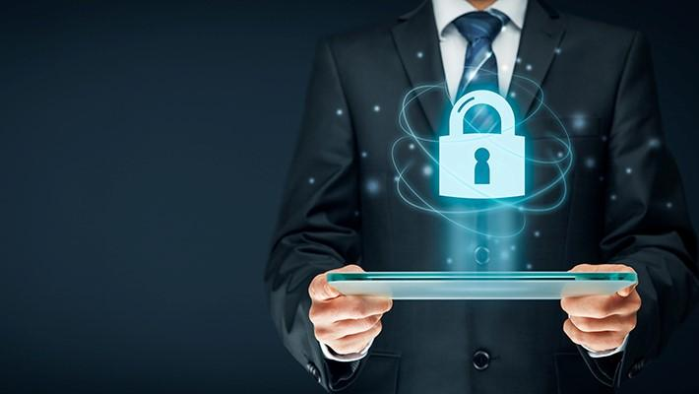
Due to the development of digital technologies, many digital threats have appeared, for example, the theft of users' personal information or hackers attacking information systems of legal entities to disable them. In response to such threats, a field of expertise has been formed designed to develop and implement technologies to protect information systems from such threats. And this area of expertise is called cybersecurity.
Picture 1. Cybersecurity
Cybersecurity (sometimes referred to as computer security or information security) is a set of methods and practices for protecting computers, servers, mobile devices, electronic systems, networks, and data from malicious attacks. Cybersecurity has applications in a wide variety of fields, from business to mobile technology.
Experts are constantly studying and analyzing crimes and threats that arise in the digital environment, as well as creating methods to counter them. For example, they are searching for vulnerabilities in corporate systems and improving encryption protocols for users' personal information.
According to experts, the cybersecurity market will only grow in the future.

1.2 The difference between cybersecurity and information security
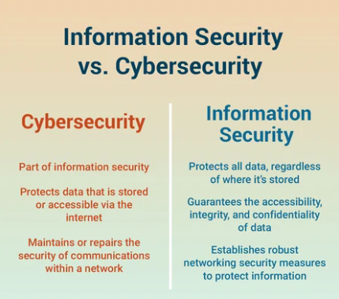
Information security protects information stored both electronically and on paper. Information security specialists are fighting both external and internal threats. For example, they try to prevent the consequences of accidental information adjustments or system malfunctions due to technical failures. Cybersecurity is the protection of digital information only and mainly from threats from outside, i.e. from Internet networks. In other words, cybersecurity is a subset of information security. Currently, digitalization affects all industries and social spheres, and therefore ensuring the security of information is impossible without protecting it from cyber threats. Information security and cybersecurity are related and complement each other, and therefore, for practical purposes, these concepts are sometimes used synonymously. Often in organizations, especially small ones, both of these areas are led by one employee.
Picture 2. The difference between cybersecurity and information security

1.3 Cybersecurity objectives
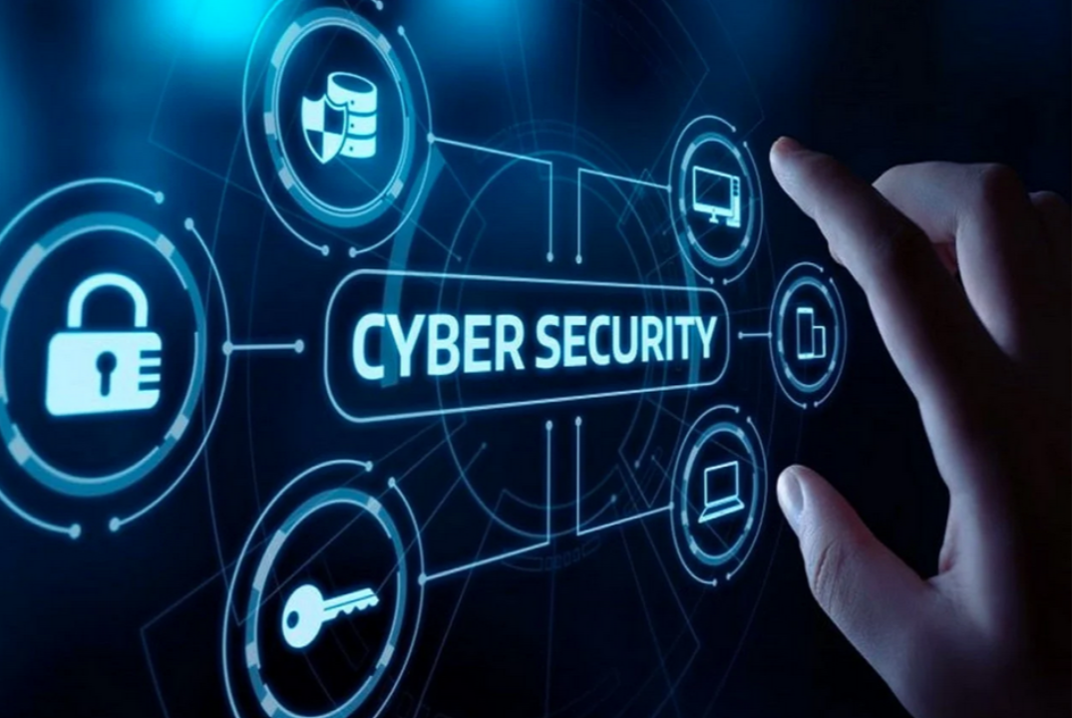
Ensuring the security of networks, devices, and software
The objects of protection against cyber threats are software and databases of legal entities, network architecture, websites and applications, smartphones and PCs, etc. When they are hacked, attackers can disable systems or steal information that they contain (user contacts, bank card details, etc.). They can sell the information they receive or use it for theft or blackmail. For legal entities, cyber attacks can cause financial and reputational losses. Attackers can erase customer databases or disclose their personal information on the Internet, as well as steal developments and sell them to competitors, disable the network architecture and shut down the company for a while. Cybersecurity experts use protection mechanisms at the software development stage and constantly analyze potential vulnerabilities in software, networks, and devices.
Picture 3. Cybersecurity objectives
Information protection
Information during storage and transfer must be protected from unauthorized access, for example, through a username and password, mobile phone number and address entered by the user when registering on the site — and they must not be accessible to cybercriminals. Any correction of information must be authorized by its owner. For example, only the user can change the account data. And only its administrator can add or exclude information from the customer database of a legal entity. Despite the ongoing cyber attacks, the user should not lose access to the account, and the legal entity support service should not lose access to customer contacts from the database. The CIA Triad is a model designed to ensure the security of information and systems. The three principles on which this model is based are confidentiality, integrity, and accessibility.
Threat detection and incident response
Incidents are the actions of cybercriminals that lead to a violation of information security or the failure of information systems. For example, unauthorized access to databases may result in the disclosure of confidential information. And a large number of requests to the site, which exceeds the network bandwidth, can cause its operation to be blocked. Responding to incidents, for example, can be in the form of resetting passwords of a suspicious account and restoring a backup copy of the information system after unauthorized deletion of information.
User training
Systems are subject to cyber threats not only due to internal vulnerabilities, but also due to human errors. For example, when an employee of a company connects to corporate software via a public Wi-Fi network, his username and password can be intercepted by cybercriminals. Or when he logs into his personal mail from his work PC and clicks on a suspicious link in the email, he exposes the system to the threat of a virus attack. To reduce the risks of cybersecurity violations on the part of employees, it is advisable to teach them the basics of cybersecurity — to talk about possible threats, consequences, and methods to avoid them.

- THE HISTORY OF CYBER THREATS
1940s: The calm before the storm

Launching a cyberattack in the two decades following the creation of the world's first digital computer in 1943 was not an easy task. The giant electronic machines were not networked, a limited number of people had access to them, and only a few people knew how to work with them, so there were practically no threats.
Interestingly, the theory behind computer viruses was first published in 1949, when computer technology pioneer John von Neumann suggested that computer programs could replicate themselves.
Picture 4. John von Neumann
The 1950s: Telephone fraudsters
The technological and cultural roots of hacking are as much linked to early phones as they are to computers.
In the late 1950s, the so-called "phone phreaking" emerged. People with a special interest in how phones work were called "phreakers." Phreaking covers several methods of intercepting protocols used by telecommunication network engineers for remote work.
Thus, it was possible to make free long-distance calls, avoiding paying for them. Unfortunately for the phone companies, they could not stop the scammers, although this practice eventually came to naught in the 1980s.
Phreakers became a community that even produced newsletters, and its members included such pioneers in the world of technology as Apple founders Steve Wozniak and Steve Jobs. The very foundation for digital technology was laid.

The 1960s: no changes on the Western front
The first mention of malicious hacking was recorded in the student newspaper of the Massachusetts Institute of Technology.
Even in the mid-1960s, most computers were huge mainframes enclosed in temperature-controlled, secure rooms. These machines were very expensive, so access (even for programmers) remained limited.
Nevertheless, those who had access (often students) began to make the first hacking attempts. At this stage, the attacks had neither commercial nor geopolitical benefits. Most of the hackers were curious bullies or those who sought to improve existing systems by making them work faster or more efficiently.
In 1967, IBM invited schoolchildren to try out their new computer. After studying the accessible part of the system, students began to dig deeper, learning its language and gaining access to other parts of it. It was a valuable lesson for the company, which expressed appreciation to "several high school students for their irresistible desire to blow up the system." This led to the development of protective measures and, perhaps, laid the foundations for a focus on security that developers will need from then on. Ethical hacking, or hacking, is still practiced today.
As computers began to shrink in size and become cheaper, many large companies began investing in data storage and management technologies. Keeping them under lock and key became unnecessary as more and more people needed access to them. Passwords began to be used.
The 1970s: the birth of computer protection
The history of cybersecurity begins in 1972 with the ARPANET (Agency for Advanced Research Projects Network) research project, the forerunner of the Internet.
Researcher Bob Thomas created a computer program called Creeper that could navigate the ARPANET network, leaving a navigation chain behind. She left a note: "I'm the creeper, catch me if you can."
Ray Tomlinson, the inventor of email, wrote the Reaper program that harassed and deleted Creeper. The Reaper program was not only the first example of antivirus software, but also the first self-replicating program, making it the first computer worm.
As dependence on computers and networks has grown, it has become clear to governments that security is crucial, and unauthorized access to data and systems can have disastrous consequences.
The concept of cybersecurity reached a mature stage by the mid-1970s. In 1976, the publication Operating System Structures to Support Security and Reliable Software stated: "Ensuring security has become an important and complex task in the design of computer systems."
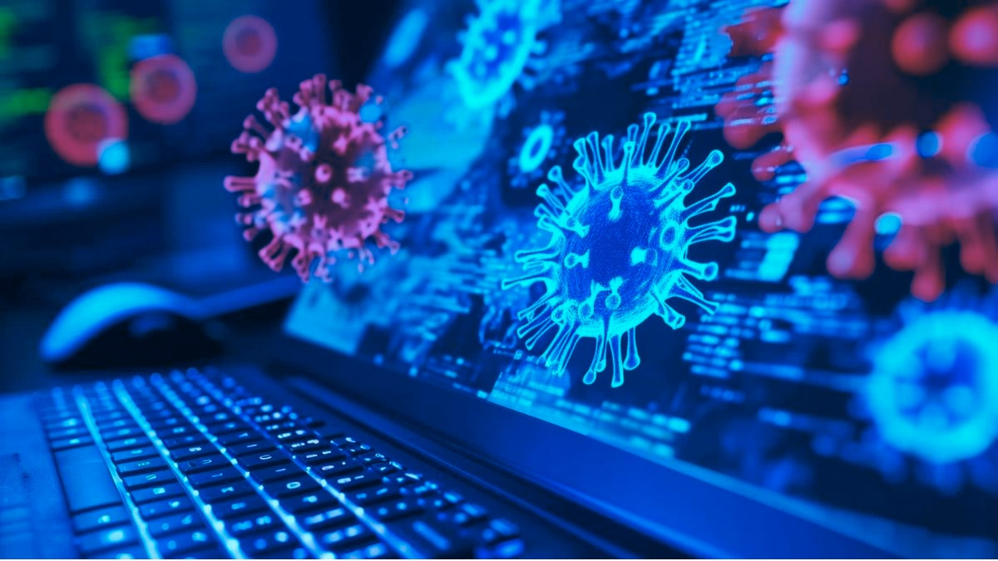
The 1980s: from ARPANET to the Internet
In the 1980s, the number of high-profile attacks increased. In 1983, the film "War Games" was released, in which a rogue computer program captures nuclear missile systems under the guise of a game. In the same year, the terms "Trojan horse" and "computer virus" were used for the first time.
Picture 5. Computer virus
During the Cold War, cyber espionage threats developed. In 1985, the U.S. Department of Defense published "Criteria for determining the security of computer systems."
Despite this, in 1986, German hacker Markus Hess used an Internet gateway in the California city of Berkeley to connect to the ARPANET. He hacked into 400 military computers, including mainframes at the Pentagon, intending to sell information to the KGB.
Security has been taken more seriously. Experienced users quickly learned how to monitor the file size. command.com after noticing that the increase in its size was the first sign of a potential infection. Cybersecurity measures have incorporated this mindset, and a sudden reduction in free RAM remains a sign of an attack to this day.
In 1987, the first commercial antivirus appeared, although there is debate about the identity of the inventor of the first antivirus product.

The 1990s: the world goes online
Cybercriminals took into account the appearance of an increasing number of antivirus scanners on the market, and in 1992 the first program appeared to combat antiviruses themselves. The number of new viruses and malware increased dramatically in the 1990s, from tens of thousands at the beginning of the decade to 5 million annually by 2007. By the mid-90s, it became clear that cybersecurity should be widespread.
By the end of the 1990s, e-mail began to spread rapidly. She promised to revolutionize the world of communications, but she also opened a new entry point for viruses. In 1999, the Melissa virus appeared. He got to the user's computer through a Word document, and then sent his copies by e-mail to the first 50 addresses from Microsoft Outlook. It remains one of the fastest-spreading viruses, and it cost about $80 million to repair the damage.
The 2000s: Threats are becoming more diverse and numerous
The Internet is becoming available in more and more homes and offices around the world, so cybercriminals have unprecedented opportunities to exploit device and software vulnerabilities. More and more data was stored digitally. In other words, there were more and more potential prey.
In 2001, a new method of infection appeared. Users no longer needed to download files, it was enough to visit the infected site. The attackers replaced blank pages with infected ones or hid malware on respectable web pages.
Another innovation of this decade was the protection of the operating system, a cyber defense built into the operating system and providing an additional level of security. This often involves regularly updating the OS, installing patches, updating antivirus mechanisms and software, having firewalls and secure user-managed accounts.
The 2010s: a new generation
The 2010s were marked by many high-profile leaks and attacks that affected the national security of countries and cost companies millions.
The 2020s: The modern Cyberworld
On a monthly basis, you can see news about how user data from various services is being leaked, and huge databases of users' personal data are going online: from email to passport data.
Every day, many companies are subjected to DDoS attacks, thereby services "fall" indefinitely. Every day, cybersecurity officers struggle with problems and try to protect themselves from attacks.

- THE MAIN TRENDS IN CYBERSECURITY
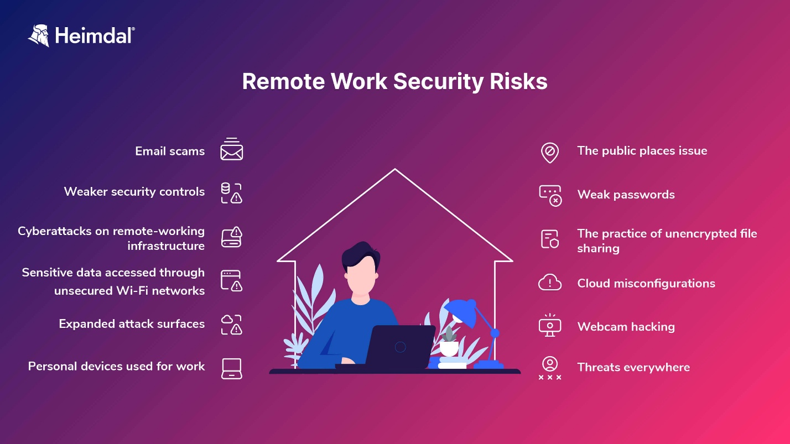
3.1 Cybersecurity risks when working remotely
The Covid-19 pandemic has forced most organizations to transfer employees to remote work, often on a fairly short schedule. Many studies show that after the pandemic, most employees will continue to work remotely.
Picture 6. Remote work security risks
Working from home creates new risks and is one of the most discussed trends in cybersecurity. The protection of home offices is usually much lower than that of centralized ones, which are usually equipped with network screens and routers, and access control is regulated by the IT security group. Switching to remote work was done in a hurry so as not to disrupt work processes, and security checks could be performed less strictly than usual. Cybercriminals can take advantage of this.
Many employees use personal devices for two-factor authentication, and they may well use mobile versions of instant messaging apps such as Microsoft Teams and Zoom. Blurring the boundaries between personal and professional life increases the risk of confidential information falling into the wrong hands.
Therefore, an important trend in cybersecurity is to draw the attention of companies to the security problems that have arisen as a result of the transition to remote work.

3.2 The increase in the number of ransomware programs
Ransomware is not a new threat, they have been around for about two decades, and their number continues to grow. It is estimated that there are currently more than 120 families of ransomware, and attackers have mastered the art of hiding malicious code perfectly. Ransomware is a relatively easy way for attackers to gain financial benefits, which partly explains the increase in their number. Another factor was the Covid-19 pandemic. In many organizations, the accelerated transition to digital technologies combined with remote work has led to new ransomware attacks. As a result, both the number of attacks and the amount of ransom required have increased.
During the attack, the attackers steal the company's data and then encrypt it so that the company cannot access it. After that, cybercriminals blackmail the company with the disclosure of confidential data if a ransom is not paid. Such attacks cause significant damage, given the confidentiality of data, as well as the economic consequences of paying a ransom.
In 2020, ransomware made history as the cause of the first recorded death as a result of a cyberattack. During the attack on a hospital in Germany, access to the systems was blocked, making it impossible to treat patients. As a result, a woman in need of emergency care was taken to a nearby hospital 20 miles away, but did not survive.
Phishing ransomware attacks are becoming more sophisticated due to machine learning and more organized data exchange on the darknet. Attackers usually demand a ransom in cryptocurrency, which is difficult to track.

3.3 An increase in the number of cloud services and threats to the security of cloud infrastructure
Vulnerability of cloud infrastructure remains one of the main trends in cybersecurity. The rapid widespread shift to remote work during the pandemic has dramatically increased the need for cloud services and infrastructure, which has affected the security of organizations.
Cloud services have a number of advantages: scalability, efficiency and cost savings, but at the same time they are the main target for intruders. Incorrectly configured cloud service settings can cause data leaks, unauthorized access, insecure interfaces, and account hacking.
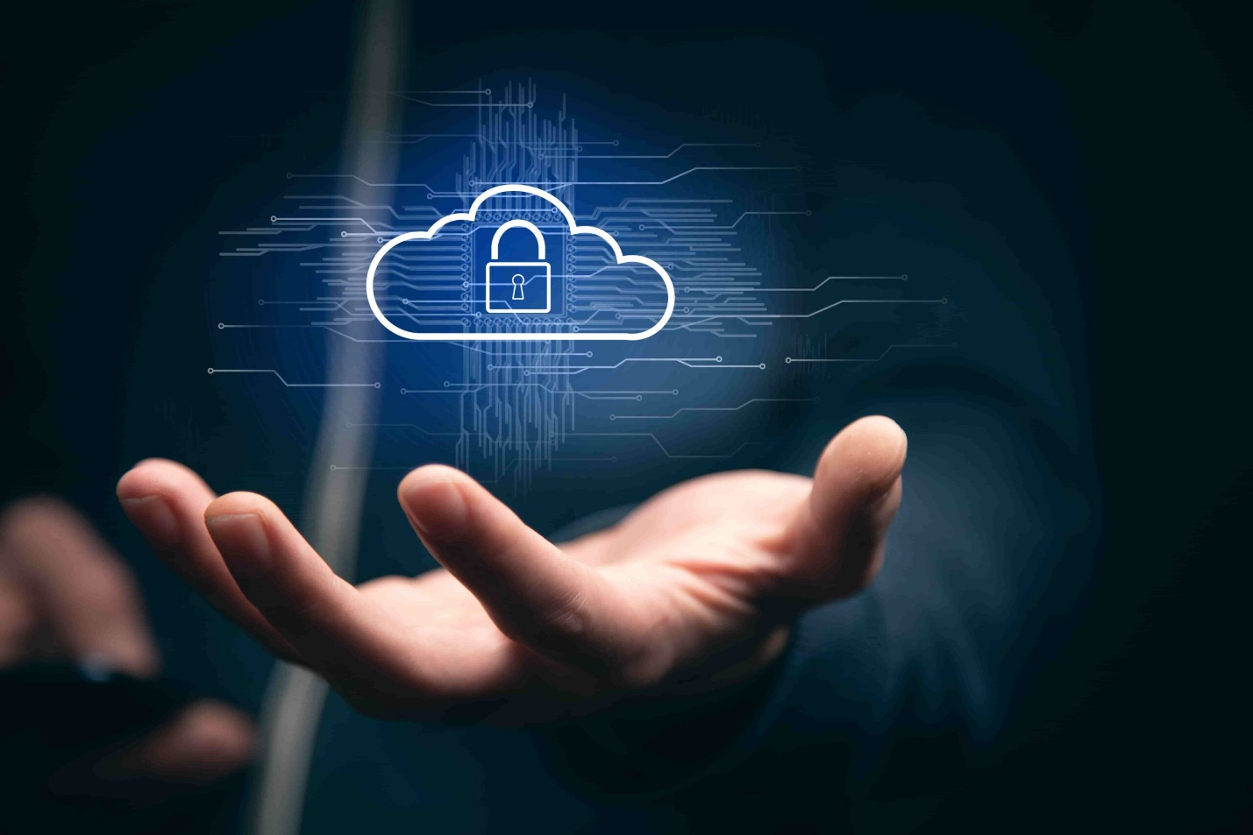
Picture 7. Security of cloud infrastructure
The average cost of a data leak is $3.86 million, so organizations need to take measures to minimize cloud threats.

3.4 Smart Social Engineering Attacks
Social engineering attacks such as phishing are not new, but they pose serious threats in the context of widespread remote work in recent years. The attackers target employees who connect to the employer's network from home, as they are the easiest victims. In addition to the traditional phishing attacks on employees, there has been a surge in attacks on the organization's leadership.
The growing use of messaging applications such as WhatsApp, Slack, Skype, Signal, and WeChat has led to an increase in the popularity of SMS phishing (smishing). Attackers use these platforms to force users to download malware on their phones.
There is also voice phishing (vishing, from "voice phishing"), which gained notoriety after the hacking of Twitter in 2020. Hackers pretended to be employees of the IT department, called customer support representatives and tricked them into providing access to important internal tools. Voice phishing has been used in attacks on many companies, including financial institutions and large corporations.
In addition, SIM card substitution is used, a type of fraud where attackers contact representatives of a particular customer's mobile operator and convince them that the SIM card has been hacked. This leads to the need to transfer the phone number to another card. If the deception is successful, cybercriminals will gain access to the digital contents of the victim's phone.
Organizations are strengthening their protection against phishing, and attackers are constantly looking for new ways to stay one step ahead: for example, they use sophisticated phishing kits that attack victims based on their location.

3.5 Data privacy as a discipline
One of the key trends in the field of data security is the allocation of data privacy in an independent direction. Numerous high-profile cyber attacks have led to the disclosure of millions of records of identification information. At the same time, stricter data protection laws are being adopted in the world, such as the General Data Protection Regulation (GDPR) adopted in the European Union, which indicates an increasing priority for data privacy.
Organizations that do not comply with regulatory requirements and do not meet consumer expectations run the risk of receiving fines, earning a negative reputation and losing customer trust. Data privacy affects almost all aspects of an organization's business. As a result, organizations are paying more attention to data privacy issues: role-based access control, multi-factor authentication, data encryption during transmission and storage, network segmentation, and external assessments to identify areas for improvement.

3.6 Improving multi-factor authentication
Multi-factor authentication is considered the gold standard of authentication. However, attackers are finding new ways to circumvent it, in particular, authentication via SMS or phone call. In 2020, Microsoft recommended that users stop using multifactor authentication over the phone, and instead use application-based authenticators and security keys.
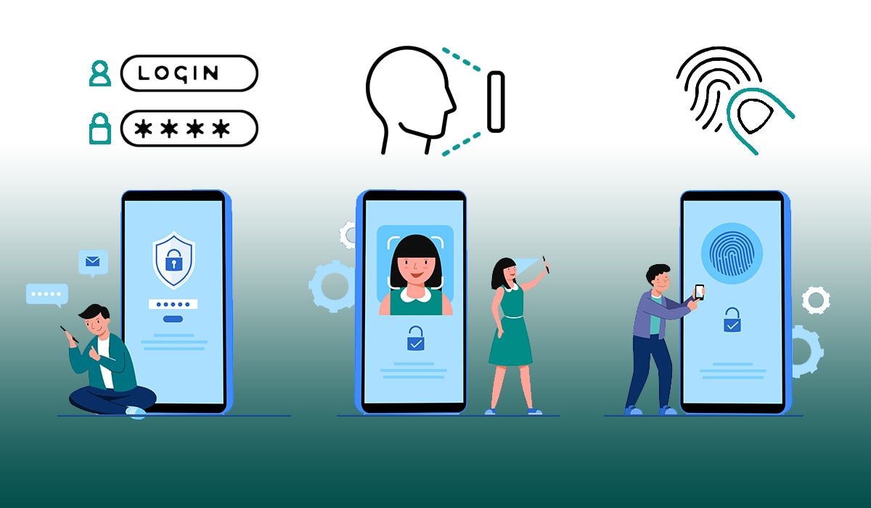
SMS messages have some built-in protection, but the messages sent, including for authentication purposes, are not encrypted. This means that attackers can perform automated man-in-the-middle attacks to obtain one-time plaintext passwords.
Picture 8. Multi-factor authentication
This is a vulnerability, particularly for online banking, where authentication is often performed via SMS. To solve this problem, banks and other organizations are increasingly trying to use multi-factor authentication based on applications: Google Authenticator, Authy, and others.

3.7 The active growth of artificial intelligence
The number of cybersecurity threats is too high, and people cannot deal with them alone. As a result, organizations are increasingly turning to artificial intelligence and machine learning in order to optimize their security infrastructure. This reduces losses: organizations affected by data breaches, which have fully deployed artificial intelligence technology, saved an average of $3.58 million in 2020.
Artificial intelligence plays a primary role in the creation of automated security systems, natural language processing, facial recognition and automatic threat detection. It also allows you to analyze huge amounts of risk data at high speed. This is beneficial both for large companies working with large amounts of data, and for small and medium-sized companies whose security groups may lack resources.
Artificial intelligence provides companies with ample opportunities to detect threats more effectively, but attackers also use it to automate attacks using methods of data distortion and model theft.
But also recently, artificial intelligence can negatively affect the lives of many users. Modern artificial intelligence models are capable of generating photos, videos, and audio fragments, so many attackers use this tool to fake data.

- TIPS FOR PROTECTING AND PREVENTING CYBER THREATS
For companies:
- Antivirus Software
- Antivirus software plays a critical role in protecting against threats. These tools are designed to detect, block, and remove malware.
- Choosing the right software: Choosing a reliable antivirus based on up-to-date signature databases and heuristic analysis methods.
- Regular updates: It is important to update signature databases regularly to detect new threats. Keeping programs updated is a key point.
- System Scan: Periodic scanning of computers and servers for malware helps to identify and remove infections.
- User Education: Users should also be trained to recognize potentially dangerous situations and be careful when downloading files and opening attachments.
- Employee training
Training employees about cybersecurity rules is an important aspect in ensuring the security of an organization. This helps reduce the risk of social engineering, phishing, and recent attacks.
- Creation of training programs: Development of training courses and materials covering the main aspects of cybersecurity and current threats.
- Conducting trainings: Organizing regular trainings and simulations to test employees' reactions to potential attacks.
- Building a safety culture: Maintaining a safety culture in an organization where employees understand the importance of following rules and precautions.
- Multi-factor authentication
Multi-factor authentication (MFA) adds an additional layer of protection by requiring two or more methods to verify a user's identity.
- Using multiple factors: An MFA may include a password, biometric data, one-time codes, or physical keys.
- Unauthorized Access Prevention: MFA makes account hacking more difficult and increases security.
- Deploying important accounts: It is important to use MFAs on accounts with access to sensitive information, including email, banking, and corporate accounts.
- Network activity monitoring and incident response
Continuous monitoring of network activity and incident response readiness are critical aspects of ensuring security. It includes:
- Establishment of monitoring systems: Deployment of tools capable of monitoring anomalies in network activity and potential incidents.
- Response plan: Develop an action plan for rapid and effective incident response, including isolation of infected systems and incident analysis.
- Cooperation with criminal authorities: Cooperation with local and international authorities to combat cybercrime in case of serious incidents.
- Control access
Delineating employee access rights and minimizing privileges can reduce the risk of internal threats.
- Use data encryption
Encrypting data at rest and in transmission provides an additional layer of security.
- Cooperate with organizations
Joining communities or sharing information with cybersecurity organizations can provide access to current threats and protection methods.
For users:
- Be careful with links
Links in emails are a common tool used by hackers to trick people into giving up their protected information. This often happens in the form of bank statements, flight bookings, password recovery emails, etc.
If a user clicks on one of these links, they end up on a fake website that is very similar to its real counterpart. The site will ask them to log in or enter their personal information. As soon as the hacker gets this information, he will gain access to the user's account.
So be aware of the links in your emails. If something looks suspicious, don't click on it. In fact, the safest option is to visit the provider's website directly rather than using an email link.
- Change passwords
Although it's easier to remember one password for all your accounts, it's not the safest one. It is best to change the password for each website and account you use. This way, if the company you are using is hacked, the stolen credentials will not work on other sites. If you're wondering how you could possibly remember all these passwords, you're not alone. But that brings us to the third tip.

- Use a password manager
A password manager is a program that stores all your passwords in one place. You have one "master key" password to unlock access to these passwords. With a password manager, you don't have to worry about remembering each of your passwords.
LastPass, KeePass, Dashlane, 1Password and Roboform are good programs. Many offer free versions, and some are completely free. And, if you use Dropbox, Skydrive, Google Drive or the like, you can save the password database on your cloud drive and it will be available anywhere.
- Set up multi-factor authentication
Without setting up multi-factor authentication (MFA), a user can access their account using only a username and password. But MFA adds another layer of protection. More than one authentication method is required to verify the user's identity when logging in.
One example of an MFA is when a user logs into a website and has to enter an additional one–time password. This one-time password is usually sent to the user's email address or phone. Setting up an MFA creates layered protection, making it difficult for unauthorized access to your information.
- Do not save payment information
Many websites allow you to save credit card information to make future purchases faster and easier. Don't do this. Violations happen all the time. There is nothing to steal if your credit card is not saved on the site. This may seem like a problem, but we promise it's not as bad as stealing your information.
- Keep your systems up to date
Your software, operating system, and browser should always be up to date. If your company uses a firewall, the firewall software and firmware must also be updated. The older the system, the more time hackers have to find vulnerabilities. By updating your systems, you will prevent malware or hackers from exploiting these security vulnerabilities.
So, the next time you see a pop-up window with a system update, don't ignore it!
- Avoid unknown sites
In this age of social media, it's easy to share a link online. But be careful when visiting new sites. It is possible that "download attacks" are being carried out on these sites that may threaten your data.
In a disk download attack, the user does not even need to click on anything so that the computer can become infected. It is enough just to visit the website to transfer the malicious code. So, it's best to stick to well-established sites that you trust. Although these sites can also be hacked, it is unlikely.
- Be careful on social media
Social media is a great way to keep in touch with friends and family. But remember what you share online. Criminals and hackers can learn a lot of information about you by watching your public profile. And just like you wouldn't share all your personal information with a stranger, you shouldn't share it online.
- Install antivirus software
Viruses, spyware, malware, phishing attacks, and more. There are so many ways your data can be compromised. Installing antivirus software on your device will help combat these attacks. Make sure that the software is active and up-to-date, and that it should prevent digital security threats even before they occur.
- Avoid unnecessary downloads
Downloads are the main tactic hackers use to gain access to your network. To protect your computer and your data, limit the number of downloads. Any unnecessary software or browser extensions should be avoided. And in an organization, employees need authorization before downloading anything from the Internet.
If you think the download is safe, always choose an individual installation and watch carefully. If any add-ons or extensions appear during the automatic installation, reject them.
- Always be on your guard
Although many things on the Internet are safe, it's best to be safe. Be aware of any links you click, the software you download, and the sites you visit. A little healthy paranoia about email, social media, and the internet can help you catch things that would otherwise elude you.

- CONCLUSION
Cybersecurity is not just a technological challenge, but a strategic necessity for business, government, and society. In an environment where digital threats affect people's lives (from finance to health), investments in data protection and infrastructure are becoming critical. The future belongs to those who can combine technological innovation, human awareness and flexibility to respond to new challenges.
Cybersecurity has come a long way from the theoretical concepts of the 1940s to the sophisticated security systems needed today. With the development of technology, threats have become more sophisticated and their consequences more devastating.
In the project, we learned what cybersecurity is, what its goals are, the history of its development, current trends in cybersecurity in the modern world were described, and relevant tips on protecting and preventing cyber threats were given.
Companies and the average Internet user should constantly take care of their cybersecurity. This is undoubtedly a very important aspect in the modern digital world, because every year the number of cyber threats is constantly growing, and there is always a risk of being caught by intruders. Cybersecurity is definitely the future of the Internet!

- BIBLIOGRAPHY
- Cybersecurity in the digital world. https://orel.1cbit.ru/blog/kiberbezopasnost-v-tsifrovom-mire/?utm_referrer=https%3A%2F%2Fwww.google.com%2F
- Cybersecurity in the modern world: current threats and methods of protection. https://www.arsis.ru/blog/cyber-security
- Ten main trends in cybersecurity. https://www.kaspersky.ru/resource-center/preemptive-safety/cyber-security-trends
- 12 Simple Cybersecurity Tips that Will Help You Better Protect Your Data. https://ib-bank.ru/bisjournal/news/15500
- What is cybersecurity? https://www.kaspersky.ru/resource-center/definitions/what-is-cyber-security
- The history of cyber defense: from the 40s to the present day. https://blog.avast.com/ru/history-of-cybersecurity-avast#the-2010s

